1) Create one VPC,with 1 one public subnet and 1 private subnet.

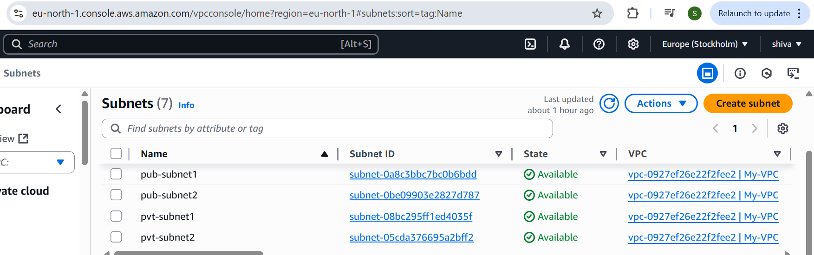

2) Enable VPC peering for cross region.

Instance of other region

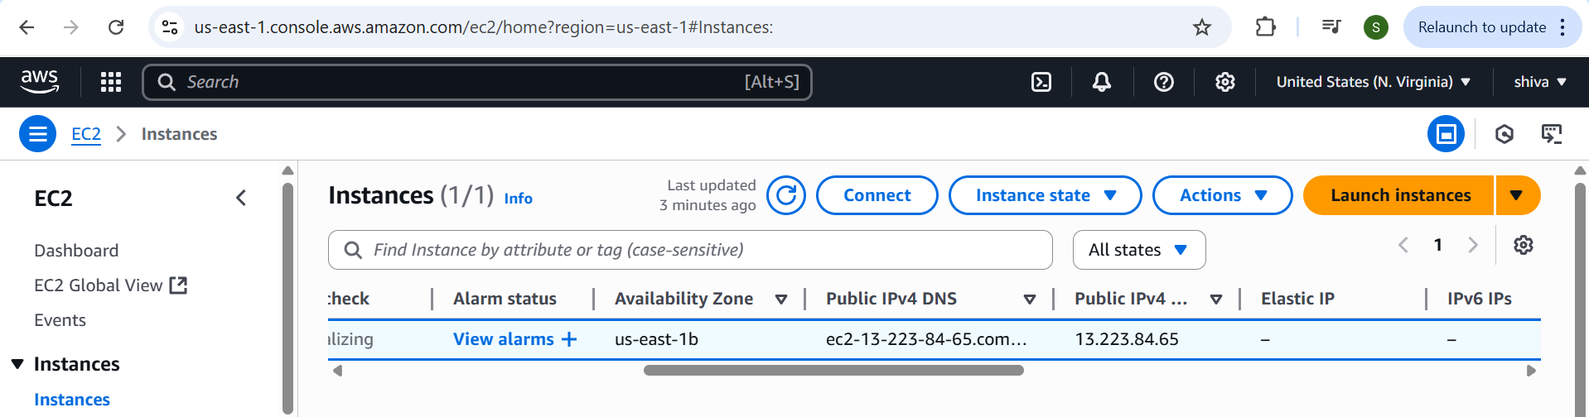

Created peering connection in my region

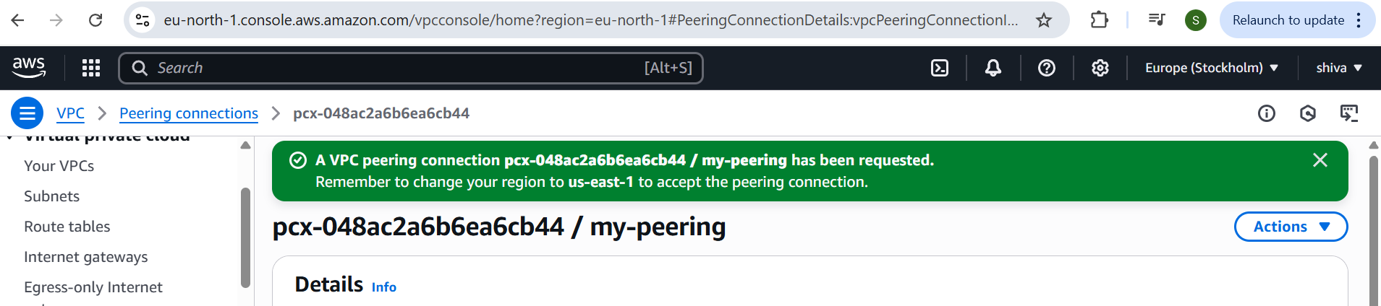

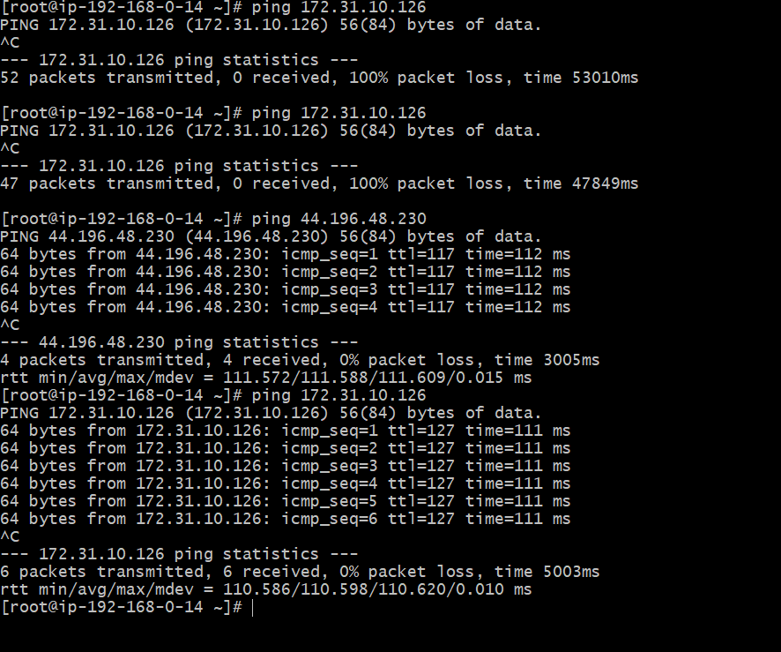

3) Enable VPC peering for cross account. (You can collaborate with your friend and do this task).

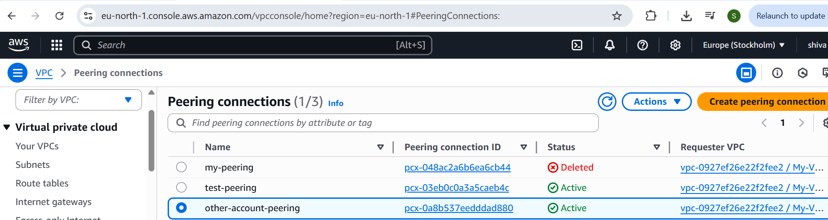

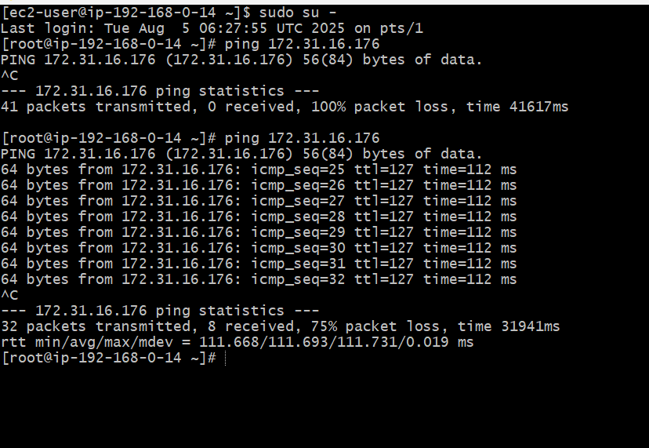

4) Setup VPC Transist gateway.

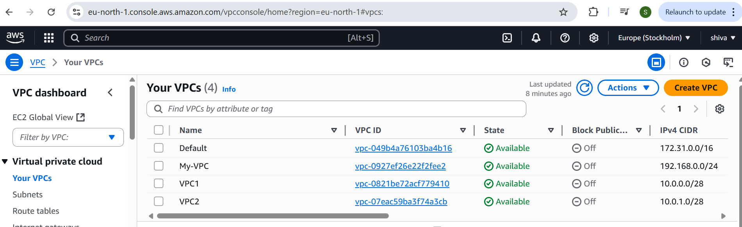

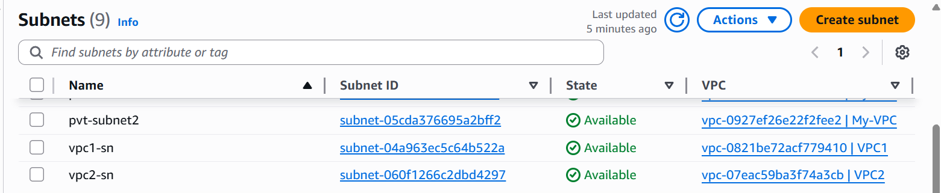

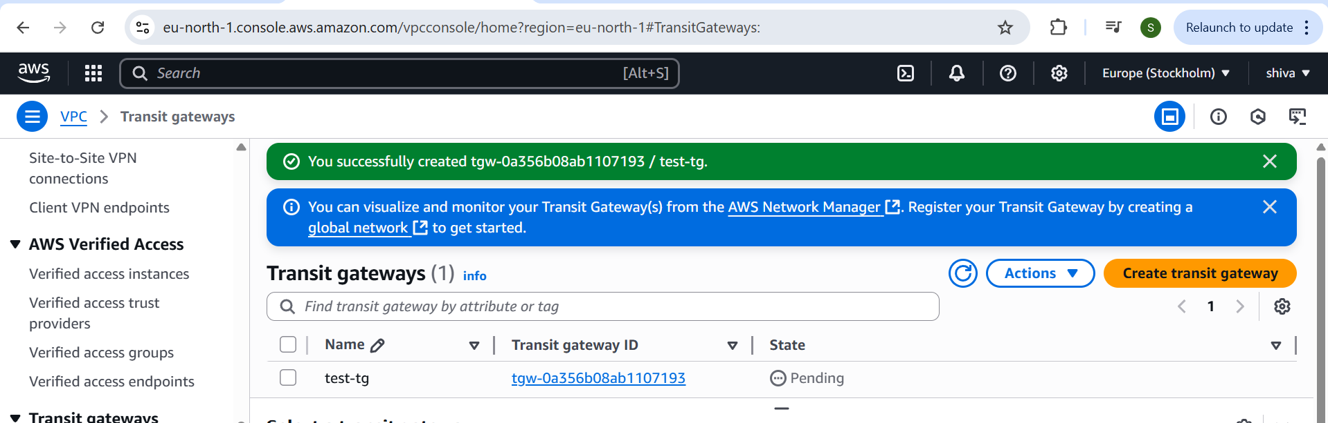

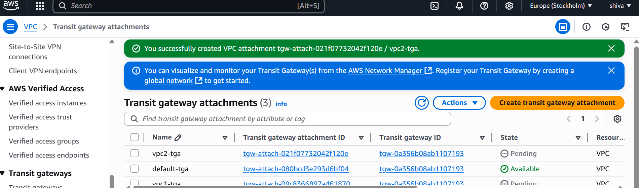

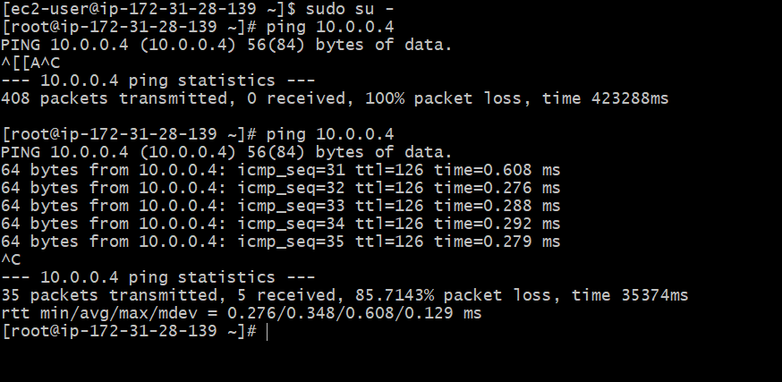

5) Setup VPC End Point.

